Atrial Fibrillation in Heart Failure Managed with Warfarin and Digoxin and Complicated by Hemorrhagic and Thrombotic Events: A Case Report from a Rural Kenyan Hospital
¹Vonwicks C. Onyango; MBChB, MMed, FCP (SA); ²Boniface Mutiso, Dip Clinical Med, MBChB(c); ³Collins P. Malalu; B. Com, MBChB; ⁴William C. Fryda; MD.
¹⁻⁴Department of Medicine, St. Joseph Rift Valley Hospital, Gilgil, Nakuru County, Kenya. P.O. Box 61-20116, Gilgil, Kenya.
Abstract
Atrial fibrillation (AF) is the most common supraventricular tachyarrhythmia. It is characterized clinically by irregularly irregular heartbeats, palpitations, dizziness, presyncope and syncope, effort intolerance, an apical-radial pulse deficit, and congestive heart failure (CHF). The diagnosis is confirmed by an electrocardiogram showing an irregularly irregular ventricular rhythm, absent P waves, and the presence of fibrillatory waves. In Sub-Saharan Africa, the prevalence of AF is about 4.3% and 0.7% in individuals aged ≥40 years and aged ≥70 years, respectively, while the main risk factors for AF are hypertension, cardiomyopathy, and rheumatic heart disease. Rate control using beta blockers, the use of antiarrhythmics, anticoagulation using warfarin or direct oral anticoagulants to prevent stroke, cardiovascular risk factor reduction, and radiofrequency catheter ablation in select patients are the main objectives in the management of AF as per the current guidelines by the European Society of Cardiology (ESC), the American Heart Association (AHA), the American College of Cardiology (ACC), etc. This case report highlights the challenges of managing AF in congestive heart failure (CHF) in a rural Kenyan hospital in which the patient had hemorrhagic complications from warfarin toxicity followed by stroke after warfarin withdrawal, and the therapeutic effects of adding digoxin to achieve better rate control and improve the CHF morbidity.

Keywords: Atrial fibrillation, CHA₂DS₂-VASc, HAS-BLED, warfarin, direct oral anticoagulants, stroke, warfarin toxicity, Kenya.
Introduction
Atrial fibrillation (AF) is characterized by a syndrome of irregularly irregular palpitations, dizziness, presyncope and syncope, effort intolerance, and features of congestive heart failure. Physical examination reveals an irregularly irregular pulse, an apical-radial pulse deficit, an absent jugular “a” wave, and variable cuff blood pressure readings [1]. The diagnosis is confirmed on an electrocardiogram (EKG), which shows an irregularly irregular ventricular rhythm (manifesting as variable R-R intervals), absent P waves, and rapid, low-amplitude, continuously varying fibrillatory (f) waves [1]. AF may be paroxysmal (self-terminating or intermittent), persistent, long-standing persistent, or permanent [1]. Common risk factors for AF include hypertension, advanced age, heart failure, valvular heart disease, diabetes, chronic lung diseases, myocardial infarction, etc. [2]. In a systematic review of the epidemiology of AF in Sub-Saharan Africa (SSA), the community-based prevalence of AF was 4.3% and 0.7% in individuals aged ≥40 years and aged ≥70 years, respectively [3]. In this study, the main risk factors for AF were hypertension, cardiomyopathy, and rheumatic heart disease (RHD), with the main complications of AF being heart failure (about 66%) and stroke (about 10-15% of cases) [3]. In SSA, the main therapeutic intervention for AF is rate control using beta blockers [3, 4]. The use of anticoagulation to reduce the risk of stroke remains suboptimal, with warfarin being preferred to the direct oral anticoagulants due to huge cost differences between the two [3, 5]. Warfarin reduces the risk of stroke in AF by up to 65% and has been the standard of care for decades [6]. In recent times, direct oral anticoagulants (DOACs) have been preferred over warfarin in stroke prevention in AF due to their more favorable efficacy and safety profiles [7]. However, in patients with AF related to RHD, the INVICTUS trial of 2022 showed that warfarin is superior to rivaroxaban in preventing major cardiovascular events (including stroke) without a higher rate of bleeding [8].The main complication of anticoagulation is bleeding, which could be mild or catastrophic. Warfarin requires close INR monitoring in order to achieve the therapeutic international normalized ratio (INR) target of 2 to 3. Due to the cost implications of the latter, therapeutic targets are frequently not achieved, especially in SSA [9]. The use of digoxin in the management of atrial fibrillation and heart failure, though still widespread, has been de-emphasized in the current guidelines to a second-or third-line agent due to concerns about its “narrow therapeutic window” and thus increased risks of toxicity and mortality in these patients [10, 11]. However, the studies that have led to these conclusions have had conflicting results and are not robust enough for conclusive evidence-based recommendations [12, 13]. The current management guidelines for atrial fibrillation have been issued by the European Society of Cardiology (ESC), the American Heart Association (AHA), and the American College of Cardiology (ACC), among other clinical societies [14]. The key perspectives from the 2023 guidelines include lifestyle and risk factor modification, the use of validated clinical risk scores to determine the annual risk of thromboembolic events (e.g., the CHA₂DS₂-VASc score), the use of bleeding risk scores to identify and modify bleeding risk factors and to inform medical decision-making (e.g., the HAS-BLED score), the use of antiarrhythmic drugs or catheter ablation, and the interplay between rate control and rhythm control [14]. See table 1 below for the CHA₂DS₂-VASc score [15].
Table 1 shows the CHA₂DS₂-VASc score [15].
Letter | Clinical characteristics | Points
C | Congestive heart failure | 1
H | Hypertension | 1
A2 | Age ≥ 75 years | 2
D | Diabetes | 1
S2 | Stroke | 2
V | Vascular disease | 1
A | Age ≥ 65 years | 1
Sc | Sex category, female | 1

Key: Maximum total score = 9 points.
ESC 2010 Anticoagulation Recommendations: Score = 0, no therapy or aspirin (no therapy preferred). Score = 1, aspirin or oral anticoagulation (oral anticoagulation preferred). Score ≥ 2, oral anticoagulation.
Case Summary
Clinical Presentation, Physical examination, and Work-up
A 73-year-old widow, a mother of nine, and a subsistence farmer from Kikopey, Gilgil, Kenya, was first referred to us in March 2022 from a peripheral health center for an electrocardiogram to evaluate an irregular heart rhythm found during a clinical review. She had a 10-month history of poorly controlled hypertension, poor adherence to medications, and no other cardiovascular risk factors. Three months prior, she had developed progressive effort intolerance, exertional dyspnea, bilateral leg swelling, and paroxysms of palpitations with on-and-off dizziness but no fainting spells. She had a vague history of on-off, fleeting, non-radiating retrosternal chest pains during palpitations with no other autonomic symptoms and no stroke-like events.
Clinically, she was sick-looking, with New York Heart Association (NYHA) dyspnea grade 3. Her blood pressure was 135/106 mmHg, she had a heart rate of 195 bpm, a pulse rate of 146 bpm, a respiratory rate of 24 breaths per minute, oxygen saturation by pulse oximetry at 91% in room air, and a random blood glucose of 96 mg/dL, and she was afebrile. She was given a stat dose of oral Atenolol 100 mg (crushed and dissolved in a small amount of water) to control her heart rate urgently. This brought down the heart rate to 108-118 bpm after 1 hour. Her important cardiovascular examination findings revealed her to be in decompensated congestive heart failure with atrial fibrillation (i.e., cool extremities with a grade bipedal pitting edema, a low volume irregularly irregular pulse rhythm and a pulse deficit of 49 beats [heart rate of 156 bpm and a pulse rate of 107 bpm], elevated jugular venous pressure to about 10 cm, variable heart sounds with normal S1 and S2, and with bi-basal lung crackles on auscultation). She had no murmurs. The rest of the examination was unremarkable. A screening fundoscopy showed grade 2 hypertensive retinopathy.
Her important initial work-up showed a normal complete blood count with a hemoglobin of 12.4 g/dL, a creatinine of 1.4 mg/dL with normal serum electrolytes, a normal urinalysis with no proteinuria, a normal liver panel with a baseline INR of 0.8, and a normal thyroid profile. An electrocardiogram (EKG) showed atrial fibrillation with a ventricular rate of 156 bpm, a left ventricular hypertrophy with repolarization changes, and possible rate-related ischemic changes in the anterolateral leads. See figure 1. A chest x-ray (CXR) showed cardiomegaly with features of pulmonary edema. See figure 2. An echocardiogram was logistically not possible to obtain during this initial evaluation. An interval point-of-care cardiac ultrasound (while already on treatment) showed a left ventricular ejection fraction of 50-55%, normal biventricular and bi-atrial sizes, a hypokinetic inferior-septal wall, and mild mitral regurgitation.
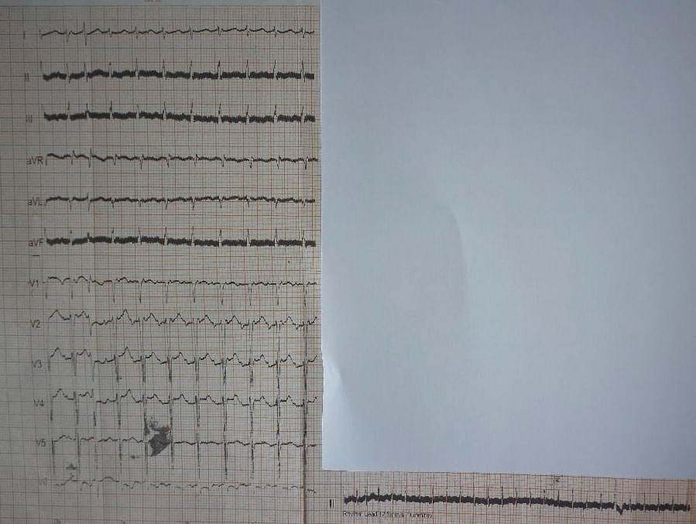
Figure 1: The first EKG in March 2022 showed atrial fibrillation with a ventricular rate of 156 bpm.
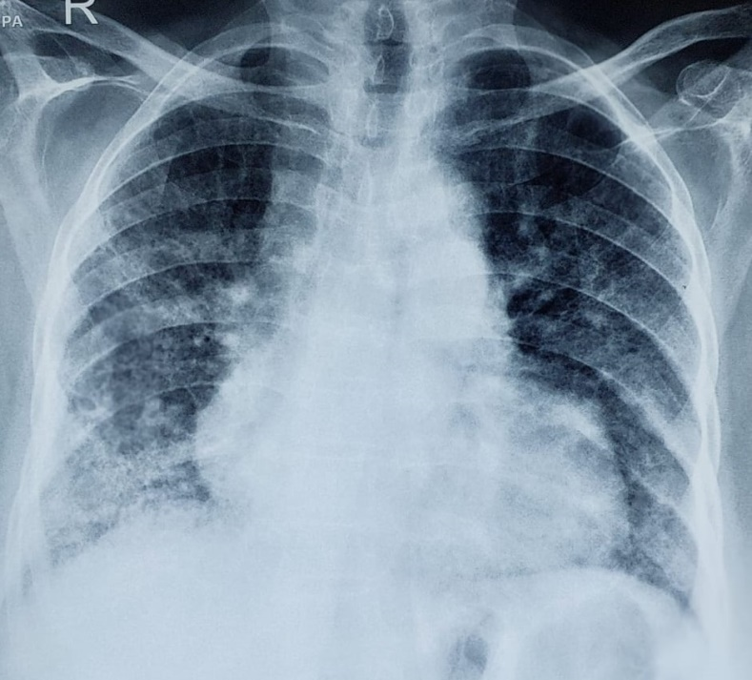
Figure 2: A CXR showing cardiomegaly and pulmonary edema with right lower lung zone opacification.
Diagnosis, Management, and Follow-up
We made a clinical diagnosis of a poorly controlled hypertensive heart disease complicated by congestive heart failure (CHF) and atrial fibrillation with rate-related ischemic changes. She was counseled on the nature of the diagnosis and management goals and put initially on oral furosemide 40 mg twice daily (BD), spironolactone 25 mg once daily (OD), enalapril 5 mg BD, carvedilol 6.25 mg BD, warfarin 2.5 mg OD (the CHA₂DS₂-VASc score was ≥6), and supportive therapy. During a clinical review two weeks later, her blood pressure was normal, the heart rate was down to 82 bpm, she was diuresing well with a serum creatinine of 1.2 mg/dL and normal electrolytes, and her INR was 1.4. By the fourth month of treatment, she had cardioverted to a normal sinus rhythm clinically, which was confirmed by a repeat EKG in September 2022. See figure 3.

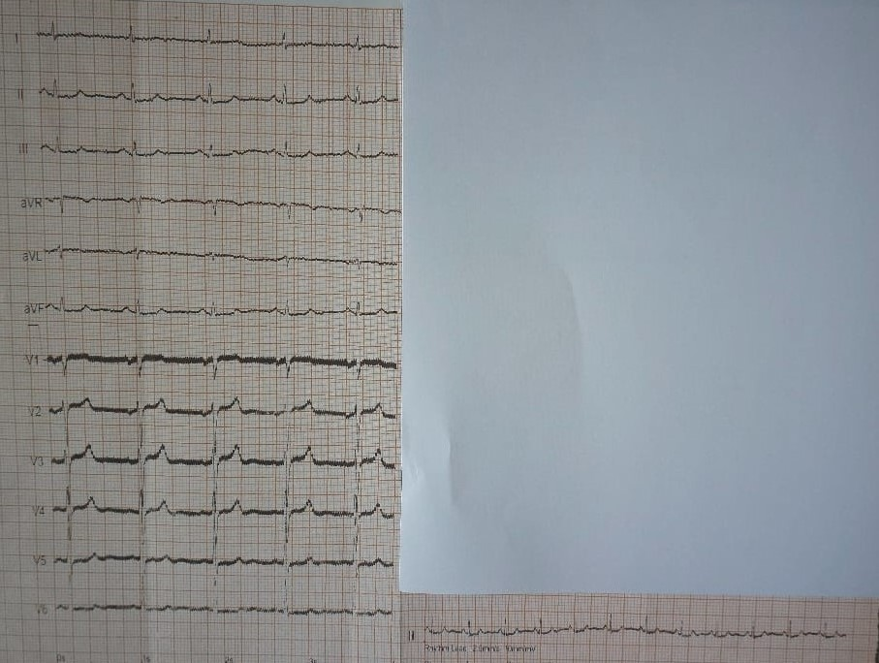
Figure 3: A repeat EKG in September 2022 showed a normal sinus rhythm with a ventricular rate of 72 bpm.
We discussed the implications of the reversal of the atrial fibrillation to a normal sinus rhythm while on treatment and advised her on a long-term anticoagulation plan. However, the patient and the family requested that we discontinue the warfarin due to the financial logistics involved with the INR measurements, which were being done monthly. We continued the warfarin for one more month and stopped it in October after the first EKG (done in September 2022) showed a normal sinus rhythm, and a repeat one a month later (October 2022) confirmed a maintained sinus rhythm. In November 2022, she was still in normal sinus rhythm. By then, she had improved clinically to a NYHA dyspnea grade 1 to 2, with appropriate adjustments of her medications to target therapeutic goals (e.g., an INR of between 2 and 3 and a blood pressure of 90-130 mmHg systolic to a diastolic of 60-80 mmHg). Her carvedilol dosage by then had been up-titrated to 12.5 mg BD. She developed enalapril-associated angioedema and was switched from enalapril to losartan.
A Catalogue of Adverse Clinical Events and Progress
Recurrence of atrial fibrillation: In late December 2022, she had an episode of community-acquired pneumonia, which precipitated the recurrence of atrial fibrillation with ventricular rates of 120-140 bpm. She was hemodynamically stable. We up-titrated the carvedilol dose to 25 mg BD and put her back on warfarin, titrated to a target INR of 2 to 3. The pneumonia was successfully treated with antibiotics as an outpatient.
Warfarin toxicity: In late January 2023, she presented acutely with warfarin toxicity (INR of 4.7), manifesting as upper gastrointestinal bleeding with hematemesis, severe anemia (hemoglobin of 5.8 g/dL), and hypotension (nadir BP of 85/31 mmHg). This was precipitated by an episode of severe septic tonsillitis, grade 3. Gastroscopy showed hemorrhagic pangastritis. This was successfully managed with blood transfusion, intravenous vitamin K 10 mg OD for 3 days, intravenous omeprazole 40 mg BD, antibiotics, and comprehensive supportive therapy. This event caused an acute kidney injury with a peak creatinine of 2.4 mg/dL and a discharge creatinine of 1.8 mg/dL. The warfarin was stopped with a view to re-starting it after 2 weeks during an outpatient review. She was hemodynamically stable, in atrial fibrillation with a ventricular rate of 70-86 bpm, and neurologically normal. The discharge INR was 1.6 off warfarin. We gave her pneumococcal vaccine, i.e., PCV-10, as this was the one available.
Transient ischemic attack: Twelve (12) days after this discharge, she was re-admitted with two episodes of transient ischemic attacks (TIA) within a 24-hour period. At this re-admission, she had right hemiparesis, leftward mouth deviation, dysarthria, and confusion. An uncontrasted CT scan of the brain showed no established infarcts or intracranial bleeding, but there were features of small-vessel chronic ischemic changes. These neurological deficits resolved within about 30 hours following treatment with atorvastatin 80 mg OD, a loading dose of clopidogrel 300 mg followed by a maintenance dose of 75 mg OD, and supportive care. She was hemodynamically stable, in slow atrial fibrillation, and the creatinine was by then 1.5 mg/dL. We considered the possible use of direct oral anticoagulant (DOAC) for anticoagulation, specifically rivaroxaban, due to its relative local availability and the subsidized costs of the generic forms, but the family could not afford it at all. We opted to put her back on warfarin, starting at 2.5 mg OD instead, because it was cheaper. We individualized her target INR to a lower value of 1.5 to 3, rather than a prior one of 2 to 3. We stopped the clopidogrel due to a high risk of bleeding (the HAS-BLED score was 5). See table 2 for the HAS-BLED score [16]. We discharged her after 4 days of being stable.
Table 2 shows the HAS-BLED score [16].
Letter | Clinical characteristic | Points
H | Hypertension (i.e., uncontrolled blood pressure) | 1
A | Abnormal renal and liver function (1 point each) | 1 or 2
S | Stroke | 1
B | Bleeding tendency or predisposition | 1
L | Labile INRs (for patients taking warfarin) | 1
E | Elderly (age greater than 65 years) | 1
D | Drugs (concomitant aspirin or NSAIDs) or excess alcohol use (1 point each) | 1 or 2
 |  | Maximum 9 points

KEY: Maximum total score = 9 points. A score of 0 indicates low risk, a score of 1–2 indicates moderate risk, and a score of ≥3 indicates high risk of bleeding.
Addition of digoxin: One month later, she presented with fast-atrial fibrillation-related palpitations and pre-syncopal episodes. Her ventricular rates were 130-150 despite being compliant on carvedilol 25 mg BD. She had an INR of 1.9. This event was precipitated by acute cystitis, which was successfully treated with oral ciprofloxacin. However, the ventricular rates remained above 120 bpm, with a BP of 85-92/50-62 mmHg in subsequent reviews. Her creatinine stabilized at 1.1 to 1.3 mg/dL. To achieve rate control, we considered either oral amiodarone (which could be obtained in town but was prohibitively expensive and would inhibit warfarin metabolism and possibly lead to warfarin toxicity again), or digoxin (which was readily available in the hospital and cheap but needed careful monitoring in view of the mild renal dysfunction). We therefore added oral digoxin 0.125 mg OD to her treatment with an initial 2-week, then monthly monitoring of creatinine and heart rate. The addition of digoxin achieved heart rate control rapidly within two weeks, with ventricular rates of 60-76 bpm.
Current status: It is now about 20 months later, and she remains hemodynamically stable with target INRs and normal renal functions. She has not been hospitalized for any reason during this time. She is on furosemide 40 mg BD, carvedilol 25 mg BD, losartan 25 mg OD, atorvastatin 40 mg OD, warfarin 2.5 mg OD, and digoxin 0.125 mg OD as her main medications. It is currently not possible to consider adding any of the newer heart failure therapies due to cost issues, i.e., sacubitril-valsartan or sodium-glucose co-transporter-2 (SGLT-2) inhibitors. We have discussed a referral to a cardiologist for a specialized review several times, but the patient has firmly preferred to be managed in the current primary care clinical setting.
Discussion
As per the 2023 ESC/AHA/ACC guidelines, the drug management of atrial fibrillation focuses on rate control (e.g., with beta blockers), rhythm control with select antiarrhythmic drug classes, stroke prevention with anticoagulation (preferably using DOACs), and specific indications for radiofrequency catheter ablation of atrial appendages, among other interventions [14]. Our patient first presented with atrial fibrillation (ventricular rates were in the 150-190s) in biventricular CHF and rate-related ischemic features needing urgent rate control, which was initially achieved using titrated dosages of carvedilol. Her CHF was initially presumed to be CHF with reduced ejection fraction (in view of her uncontrolled hypertension, etc.) and managed with the locally available standard 4-drug regimen of a diuretic (furosemide), a mineralocorticoid receptor antagonist (spironolactone), a beta blocker (carvedilol), and an angiotensin converting enzyme inhibitor/angiotensin receptor blocker (enalapril, which was switched to losartan due to enalapril-related angioedema) [17]. Due to a high CHA₂DS₂-VASc score, she was appropriately started on anticoagulation with warfarin (as opposed to a DOAC) due to its cheap cost and wide local availability. However, cost-related challenges affected the recommended close INR monitoring schedules and thus led to subtherapeutic targets [18]. Our patient initially cardioverted to a normal sinus rhythm by the fourth month of treatment. It is possible that the use of carvedilol could have contributed to this due to its class II antiarrhythmic properties, although this may be an overestimation. The typical antiarrhythmic agents associated with cardioversion include class Ic agents (flecainide and propafenone) and class III agents (e.g., amiodarone), etc. Each of these has several limitations [19-21]. Following cardioversion of AF, anticoagulation should be continued lifelong in patients with a high CHA₂DS₂-VASc score due to the high risks of recurrent AF episodes and subsequent stoke events in these patients [14]. Sepsis from any source is a well-established cause of coagulopathy through various pathways, including prolonged INR in patients not on warfarin, as well as a risk factor for the acute onset or recurrence of atrial fibrillation [22, 23]. For our patient, who was already on warfarin, an episode of pneumonia induced a recurrence of the AF, whereas sepsis due to tonsillitis led her to develop severe coagulopathy (warfarin toxicity) and severe hemorrhage, which was successfully managed. The occurrence of stroke just 12 days after withholding warfarin following the episode of warfarin toxicity probably reflects her high AF-related thromboembolic burden as well as additional ischemic stroke risks following the instigating sepsis (severe tonsillitis) [23]. Individualizing her subsequent target INR to a lower value of 1.5 to 2.0 is justified in view of her high HAS-BLED score. This is consistent with previous consensus guidelines [24]. The addition of digoxin with appropriate monitoring has enabled effective rate control of her AF and minimized admissions related to her CHF without any obvious digoxin-related adverse events so far [25].
Conclusion
The management of AF in CHF should focus on effective rate control, comprehensive pharmacological therapy for the CHF, anticoagulation to prevent stroke, and consultation with a cardiologist for more advanced therapies where indicated and possible. Effective warfarin therapy should achieve therapeutic INR targets of 2-3 while monitoring for bleeding complications, especially in the face of sepsis. However, lower individualized target INRs should be considered in elderly patients with a high HAS-BLED score. Where possible, DOACs may preferably be used in non-RHD patients with high risks for stroke. Patients who have cardioverted to a sinus rhythm should continue lifelong anticoagulation if they have a high CHA₂DS₂-VASc score. Digoxin remains useful in select patients but needs careful monitoring.
Acknowledgement
The authors acknowledge the hospital administrator, Mr. Seth Manera, and the laboratory and nursing staff in the female ward of St. Joseph Rift Valley Hospital, Gilgil, for their help with managing this patient.
Informed Consent
Informed consent was obtained from the patient to publish this case study.
FUNDING
The authors have no funding sources to declare.
References
1. Hindricks, G., et al., 2020 ESC Guidelines for the diagnosis and management of atrial fibrillation developed in collaboration with the European Association for Cardio-Thoracic Surgery (EACTS): The Task Force for the diagnosis and management of atrial fibrillation of the European Society of Cardiology (ESC) Developed with the special contribution of the European Heart Rhythm Association (EHRA) of the ESC. Eur Heart J, 2021. 42(5): p. 373-498.
2. Staerk, L., et al., Atrial Fibrillation: Epidemiology, Pathophysiology, and Clinical Outcomes. Circ Res, 2017. 120(9): p. 1501-1517.
3. Noubiap, J.J. and U.F. Nyaga, A review of the epidemiology of atrial fibrillation in sub-Saharan Africa. J Cardiovasc Electrophysiol, 2019. 30(12): p. 3006-3016.
4. Jardine, R.M., J. Fine, and I.W. Obel, A survey on the treatment of atrial fibrillation in South Africa. S Afr Med J, 2014. 104(9): p. 623-7.
5. Semakula, J.R., et al., Anticoagulation in sub-Saharan Africa: Are direct oral anticoagulants the answer? A review of lessons learnt from warfarin. Br J Clin Pharmacol, 2021. 87(10): p. 3699-3705.
6. Hart, R.G., et al., Antithrombotic therapy to prevent stroke in patients with atrial fibrillation: a meta-analysis. Ann Intern Med, 1999. 131(7): p. 492-501.
7. Carnicelli, A.P., et al., Direct Oral Anticoagulants Versus Warfarin in Patients With Atrial Fibrillation: Patient-Level Network Meta-Analyses of Randomized Clinical Trials With Interaction Testing by Age and Sex. Circulation, 2022. 145(4): p. 242-255.
8. Connolly, S.J., et al., Rivaroxaban in Rheumatic Heart Disease-Associated Atrial Fibrillation. N Engl J Med, 2022. 387(11): p. 978-988.
9. White, H.D., et al., Comparison of outcomes among patients randomized to warfarin therapy according to anticoagulant control: results from SPORTIF III and V. Arch Intern Med, 2007. 167(3): p. 239-45.
10. Van Gelder, I.C., et al., Rate control in atrial fibrillation. Lancet, 2016. 388(10046): p. 818-28.
11. Lopes, R.D., et al., Digoxin and Mortality in Patients With Atrial Fibrillation. J Am Coll Cardiol, 2018. 71(10): p. 1063-1074.
12. Dorian, P. and P. Angaran, Beta-Blockers and Digoxin in Atrial Fibrillation: Back to the Future. Can J Cardiol, 2023. 39(11): p. 1594-1597.
13. Ferrari, F., I. Santander, and R. Stein, Digoxin in Atrial Fibrillation: An Old Topic Revisited. Curr Cardiol Rev, 2020. 16(2): p. 141-146.
14. null, n., et al., 2023 ACC/AHA/ACCP/HRS Guideline for the Diagnosis and Management of Atrial Fibrillation. Journal of the American College of Cardiology, 2024. 83(1): p. 109-279.
15. Mason, P.K., et al., Impact of the CHA2DS2-VASc score on anticoagulation recommendations for atrial fibrillation. Am J Med, 2012. 125(6): p. 603.e1-6.
16. Pisters, R., et al., A novel user-friendly score (HAS-BLED) to assess 1-year risk of major bleeding in patients with atrial fibrillation: the Euro Heart Survey. Chest, 2010. 138(5): p. 1093-100.
17. Heidenreich, P.A., et al., 2022 AHA/ACC/HFSA Guideline for the Management of Heart Failure: A Report of the American College of Cardiology/American Heart Association Joint Committee on Clinical Practice Guidelines. Circulation, 2022. 145(18): p. e895-e1032.
18. Sonuga, B.O., et al., Profile and anticoagulation outcomes of patients on warfarin therapy in an urban hospital in Cape Town, South Africa. Afr J Prim Health Care Fam Med, 2016. 8(1): p. e1-8.
19. Echt, D.S. and J.N. Ruskin, Use of Flecainide for the Treatment of Atrial Fibrillation. Am J Cardiol, 2020. 125(7): p. 1123-1133.
20. Sestito, A. and E. Molina, Atrial fibrillation and the pharmacological treatment: the role of propafenone. Eur Rev Med Pharmacol Sci, 2012. 16(2): p. 242-53.
21. Istratoaie, S., et al., Efficacy of amiodarone for the prevention of atrial fibrillation recurrence after cardioversion. Cardiovasc J Afr, 2021. 32(6): p. 327-338.
22. Tsantes, A.G., et al., Sepsis-Induced Coagulopathy: An Update on Pathophysiology, Biomarkers, and Current Guidelines. Life, 2023. 13(2): p. 350.
23. Induruwa, I., et al., Sepsis-driven atrial fibrillation and ischaemic stroke. Is there enough evidence to recommend anticoagulation? Eur J Intern Med, 2022. 98: p. 32-36.
24. Gallus, A.S., et al., Consensus guidelines for warfarin therapy. Recommendations from the Australasian Society of Thrombosis and Haemostasis. Med J Aust, 2000. 172(12): p. 600-5.
25. Ambrosy, A.P., P.S. Pang, and M. Gheorghiade, Digoxin for Worsening Chronic Heart Failure. JACC: Heart Failure, 2016. 4(5): p. 365-367.

